
UNIT 3BCHE

CARBON CHEMISTRY

NAME: TIME ALLOWED: 60 MINUTES

Goal Mark: /40

Actual Mark: /40

Part A: Multiple Choice Questions. (10 marks)

Q1. Which of the following formulae represent a pair of isomers?
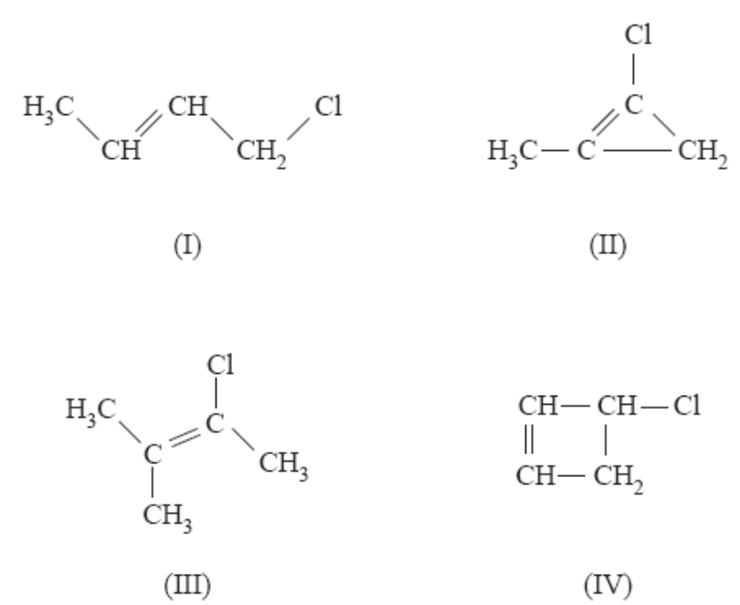

A. (I) and (II).
B. (I) and (III)
C. (I) and (IV)
#D. (II) and (IV)

Q2. When hot acidic potassium permanganate is used to oxidise an alkene, a colour change occurs.

What colour change would be observed?
A. Colourless to purple
B. Orange to brown
C. Brown to colourless
#D. Purple to colourless
Q3. What is the IUPAC name for the compound whose structure is given below?

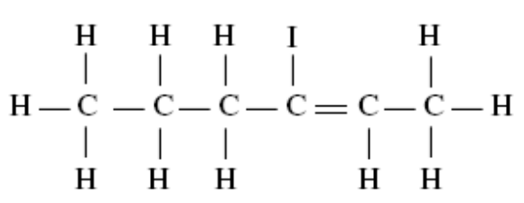

A. 4-iodo-4-hexene
#B. 3-iodo-2-hexene
C. 4-iodo-5-hexene
D. 2-iodo-2-hexene

Q4. Which of the following pairs of substances are NOT isomers?

A. 2-pentanone and 3-methylbutanal
B. butanoic acid and 1,2-cyclobutanediol
C. 3-methylhexane and 2,2,3-trimethylbutane

#D. methylcyclopentane and hexane

Q5. The structure of glycine is shown.

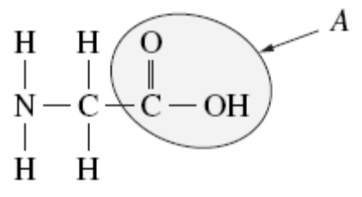

The functional group A is

A. hydroxyl group
B. ester group
#C. carboxylic acid group
D. amine group

Q6. Which of the following is a common use for ethyl pentanoate?

#A. Flavouring
B. Fuel
C. Indicator
D. Solvent

Q7. The four substances below have similar molar masses.
.
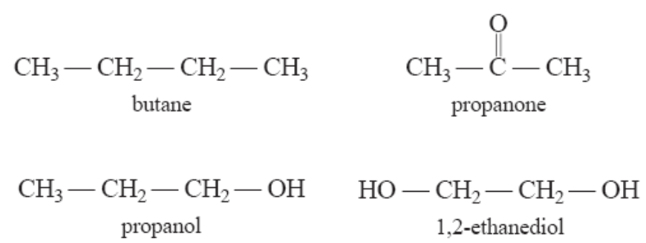

The substance with the highest boiling point is

A. butane
B. propanol
C. propanone
#D. 1,2-ethanediol

Q8. Chlorine gas is added to 2-pentene in the dark.

#C What is the major organic product?

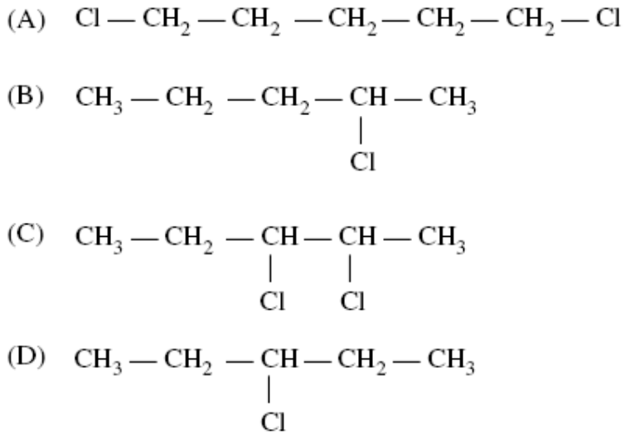

Q9. The type of polymerisation shown in the following reaction is
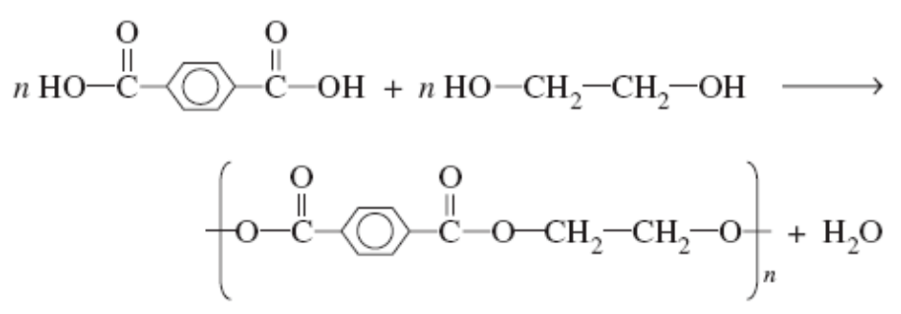
A. Addition
#B. Condensation
C. Esterification
D. Hydrolysis

Q10. A student was given the task of identifying a liquid organic compound that contains only carbon, hydrogen and oxygen. The following tests were carried out

Test 1: Some brown Br_{2(aq)} was added to a sample of the compound.
A reaction occurred and a colourless product formed.

Test 2: Some Na₂CO_{3(s)} was added to a sample of the compound.
A reaction occurred and a colourless gas was evolved.

#B Based on the above test results, the compound could be

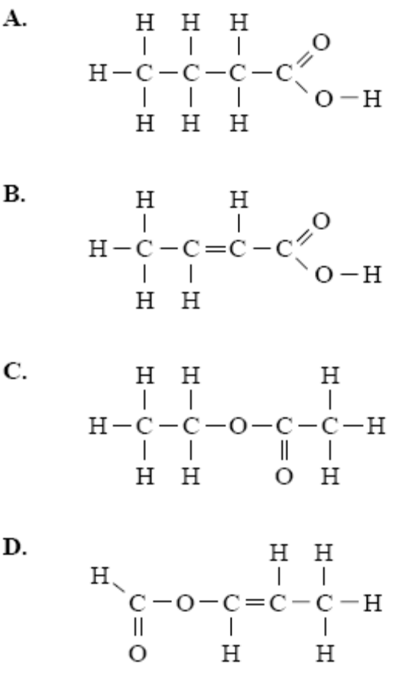

END OF PART A

PART B: SHORT ANSWER QUESTIONS (15 marks)

Q11. You have carried out a first-hand investigation to compare the reactivity of an alkene with its corresponding alkane.

A. State the name of the alkene.
(1 mark)
B. Outline a procedure to compare the reactivity of this alkene with its
corresponding alkane.

(2 marks)
C. Describe the results obtained from this first-hand investigation and include
relevant chemical equations.

(3 marks)
relevant chemical equations

Q12. Punicic acid, C₁₇H₂₉COOH, is the main alkanoic (carboxylic) acid found in pomegranate seeds. It is an unsaturated straight chain compound.

A. Deduce (work out) the number of carbon to carbon double bonds in punicic acid.

(1 mark)

B. A triglyceride can be made from punicic acid and glycerol (propan-1,2,3-triol)

Draw the structure of this triglyceride. You should represent the hydrocarbon chains in punicic acid as C₁₇H₂₉.
(1 mark)

Name the two types of functional groups in the triglyceride in B above.

& (2 marks)

C. Explain why this triglyceride is soluble in non-polar solvents such as hexane.

(2 marks)

Q13. To what class of compounds do these molecules belong?
(1 mark)
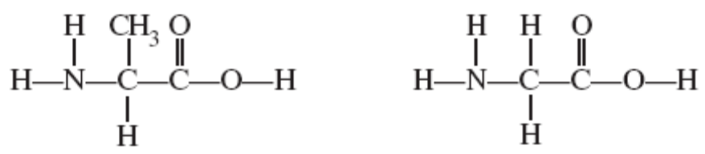
Using the two compounds above describe the formation of a peptide bond with a chemical equation. (1 mark)

Clearly indicate the peptide bond by circling it (1 mark)

PART C: EXTENDED ANSWER SECTION (15 marks)

Q14. Two different compounds A and B are isomers with the molecular formula C3H8O.
A and B undergo a series of reactions as shown below.

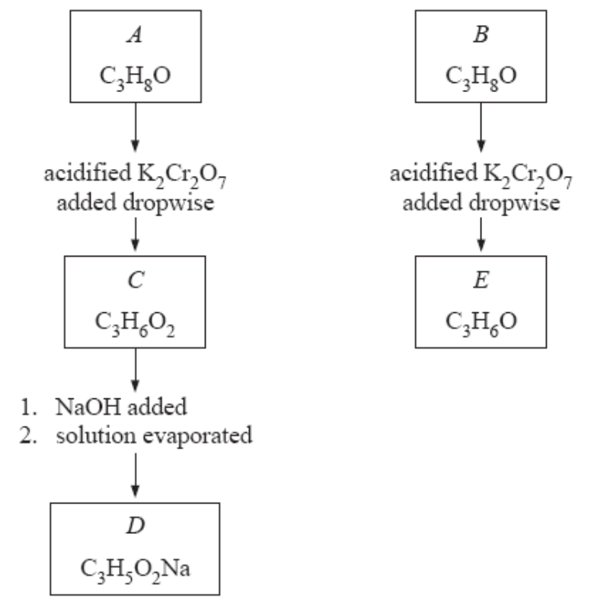
A. Draw the structural formula for C and E (2 marks)

C | E

B. How is compound A different from compound B? (2 marks)

C. Describe the colour change seen in going from A to C.

(1 mark)

D. Draw the structural formula and give the name for the compound produced if B and C react in the presence of a small amount of concentrated sulfuric acid.

(1 mark)
Name:

(1 mark)

Q15. Thiophene is a liquid compound of the elements C, H and S.

A sample of thiophene weighing 7.96 g was burned in oxygen, giving 16.65 g CO₂.

Another sample was subjected to a series of reactions that transformed all of the sulphur in the compound to barium sulfate. If 4.31 g of thiophene gave 11.96 g of barium sulfate, what is the empirical formula of thiophene?

(6 marks)

Thiophene’s molecular mass is 84 amu. What is its molecular formula?

(1 mark)

Given that thiophene is a ring or cyclic compound, draw a possible structural formula.

(1 mark)

END OF TEST
Ans: C₄H₄S, C₄H₄S

